EXPERIMENT-9
TITLE: Group by & having clause
Objective: To understand the use of group by and having clause.
Write the SQL Queries for the following queries (use EMP and DEPT table of Exp 8).
- List the Deptno where there are no emps.
Commands:
SELECT DEPTNO
FROM DEPT
WHERE DEPTNO NOT IN (SELECT DISTINCT DEPTNO FROM EMP);
Output:
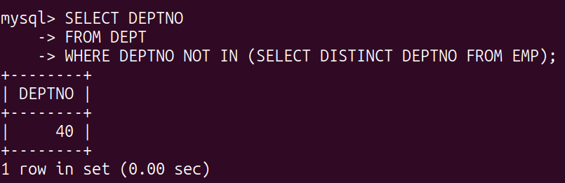
- List the No.of emp’s and Avg salary within each department for each job.
Commands:
SELECT DEPTNO, JOB, COUNT(*) AS Num_Employees, AVG(SAL) AS Avg_Salary
FROM EMP
GROUP BY DEPTNO, JOB;
Output:
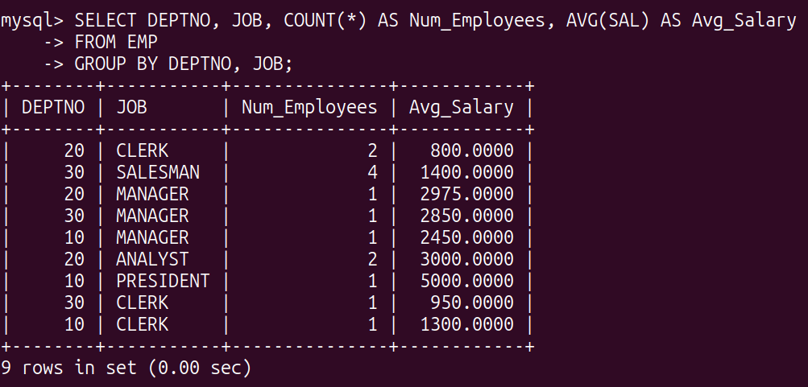
- Find the maximum average salary drawn for each job except for ‘President’.
Commands:
SELECT JOB, MAX(Avg_Salary) AS Max_Avg_Salary
FROM (SELECT JOB, AVG(SAL) AS Avg_Salary
FROM EMP
WHERE JOB != 'PRESIDENT'
GROUP BY JOB) AS Subquery
GROUP BY JOB;
Output:
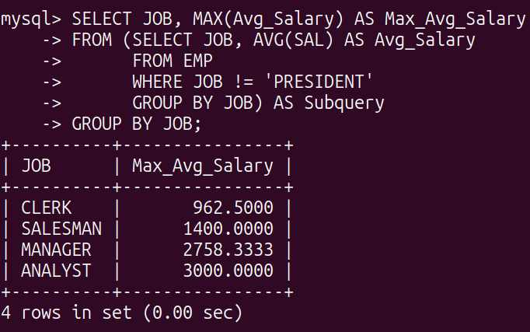

- List the department details where at least two emps are working.
Commands:
SELECT DEPTNO
FROM EMP
GROUP BY DEPTNO
HAVING COUNT(*) >= 2;
Output:

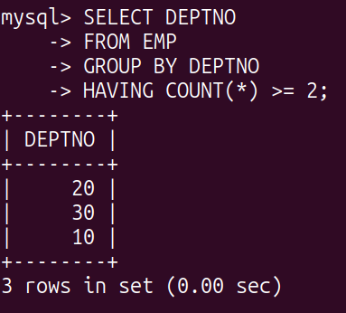

- List the no. of emps in each department where the no. is more than 3.
Commands:
SELECT DEPTNO, COUNT(*) AS Num_Employees
FROM EMP
GROUP BY DEPTNO
HAVING COUNT(*) > 3;
Output:
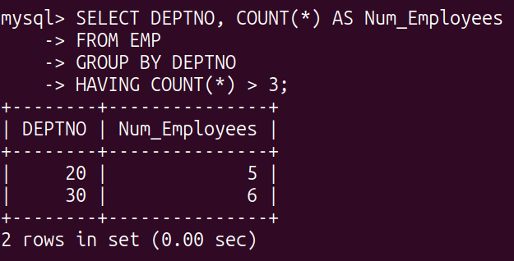

- List the names of the emps who are getting the highest sal dept wise.
Commands:
SELECT E.ENAME, E.DEPTNO
FROM EMP E
WHERE (E.DEPTNO, E.SAL) IN (SELECT DEPTNO, MAX(SAL) FROM EMP GROUP BY DEPTNO);
Output:

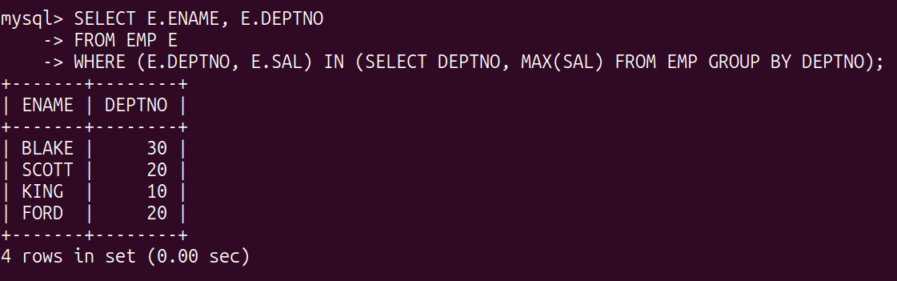
- List the Deptno and their average salaries for dept with the average salary less than the averages for all departments.
Commands:
SELECT DEPTNO, AVG(SAL) AS Avg_Salary
FROM EMP
GROUP BY DEPTNO
HAVING AVG(SAL) < (SELECT AVG(SAL) FROM EMP);
Output:
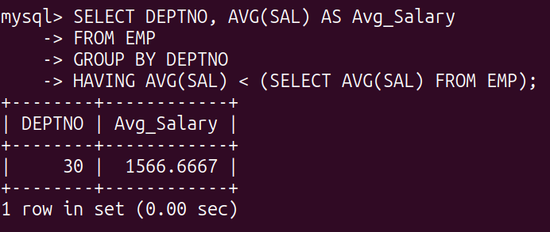

EXPERIMENT-10
TITLE: Joins in SQL
AIM: To execute and verify the SQL commands using Join.
OBJECTIVE: SQL joins are used to query data from two or more tables, based on a relationship between certain columns in these tables.
Refer Experiment 7 & 8 and execute the same questions

1. List the details of the employees whose salaries are more than the employee BLAKE.

Commands:
SELECT e.*
FROM EMP e
JOIN EMP m ON e.MGR = m.EMPNO
WHERE e.SAL > m.SAL AND m.ENAME = 'BLAKE';

Output:
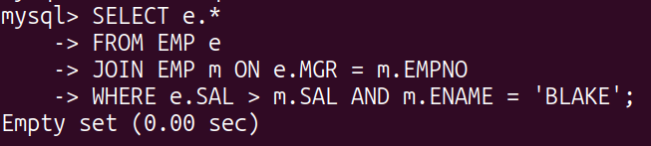

2. List the employees whose jobs are the same as ALLEN.

Commands:
SELECT e.*
FROM EMP e
JOIN EMP a ON e.JOB = a.JOB
WHERE a.ENAME = 'ALLEN';

Output:
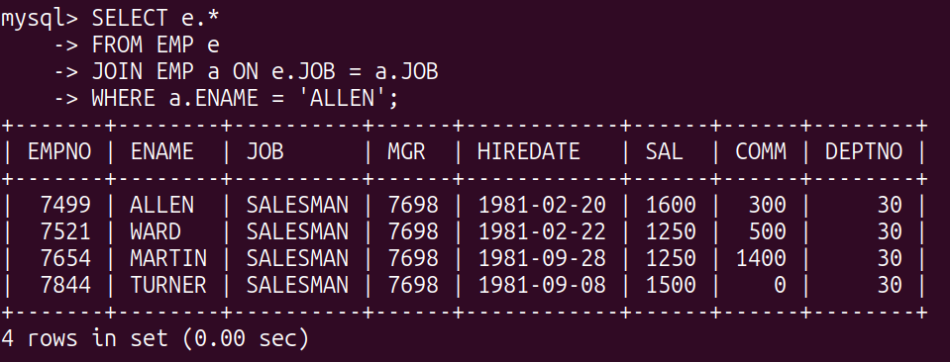

3. List the employees whose salary is the same as FORD or SMITH in descending order of names.

Commands:
SELECT e.*
FROM EMP e
JOIN EMP f ON e.SAL = f.SAL
JOIN EMP s ON e.SAL = s.SAL
WHERE f.ENAME = 'FORD' OR s.ENAME = 'SMITH'
ORDER BY e.ENAME DESC;

Output:
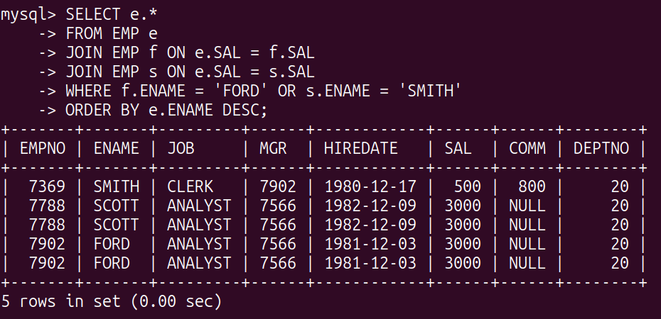

4. List the employees whose jobs are the same as MILLER or salary is more than ALLEN.

Commands:
SELECT e.*
FROM EMP e
JOIN EMP m ON e.JOB = m.JOB
WHERE m.ENAME = 'MILLER'
OR e.SAL > (SELECT SAL FROM EMP WHERE ENAME = 'ALLEN');

Output:
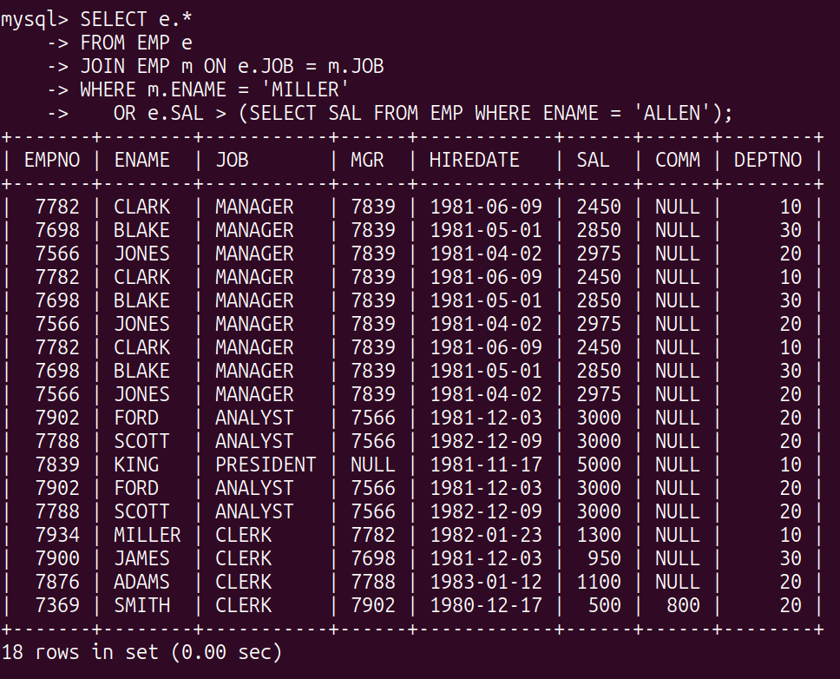

5. Find the highest paid employee of the sales department.

Commands:
SELECT e.*
FROM EMP e
JOIN DEPT d ON e.DEPTNO = d.DEPTNO
WHERE d.DNAME = 'SALES'
ORDER BY e.SAL DESC
LIMIT 1;

Output:
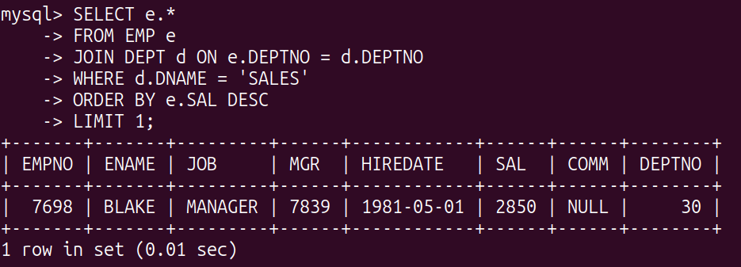

6. List the employees who are senior to the most recently hired employee working under King.

Commands:
SELECT e.*
FROM EMP e
JOIN EMP m ON e.MGR = m.EMPNO
WHERE m.HIREDATE = (SELECT MAX(HIREDATE) FROM EMP WHERE MGR = (SELECT EMPNO FROM EMP WHERE ENAME = 'KING'));

Output:
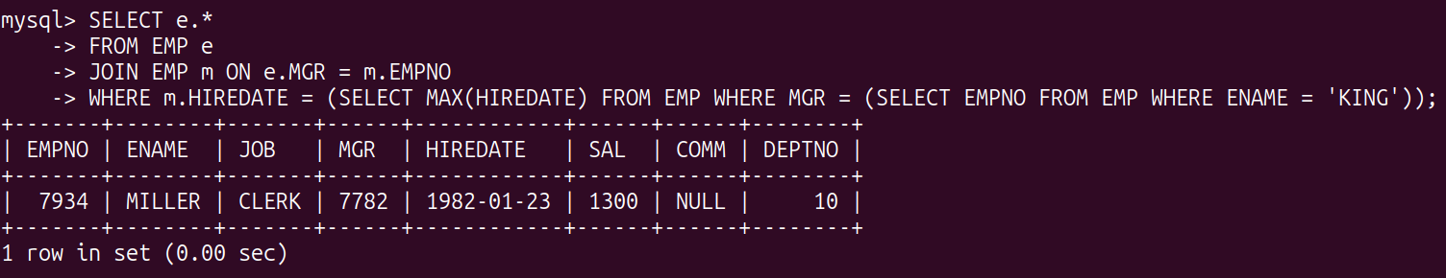

7. List the names of the employees who are getting the highest salary department-wise.

Commands:
SELECT e.ENAME, e.DEPTNO
FROM EMP e
JOIN (SELECT DEPTNO, MAX(SAL) AS Max_Sal FROM EMP GROUP BY DEPTNO) AS MaxSalaries
ON e.DEPTNO = MaxSalaries.DEPTNO AND e.SAL = MaxSalaries.Max_Sal;

Output:
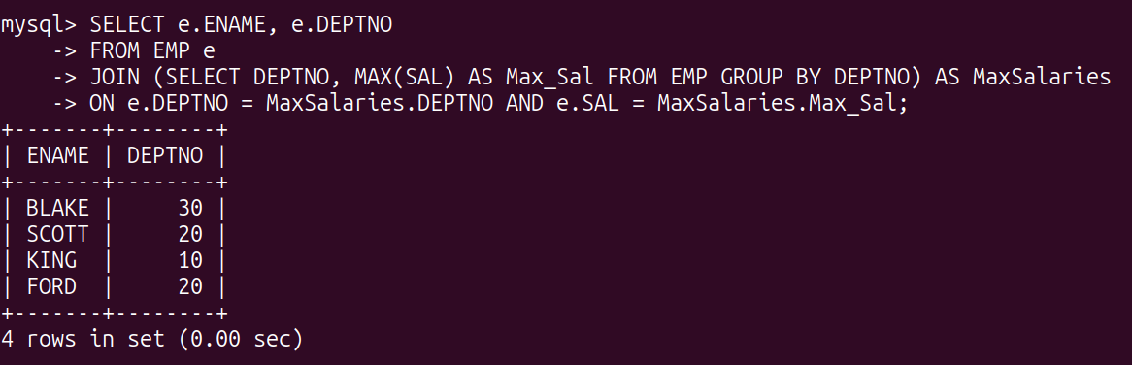

8. List the employees whose salary is equal to the average of the maximum and minimum salary.

Commands:
SELECT e.*
FROM EMP e
WHERE e.SAL = (SELECT (MAX(SAL) + MIN(SAL)) / 2 FROM EMP);

Output:
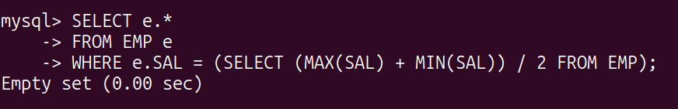

9. List the employees who joined the company on the same date.

Commands:
SELECT e1.*
FROM EMP e1
JOIN EMP e2 ON e1.HIREDATE = e2.HIREDATE AND e1.EMPNO != e2.EMPNO;

Output:
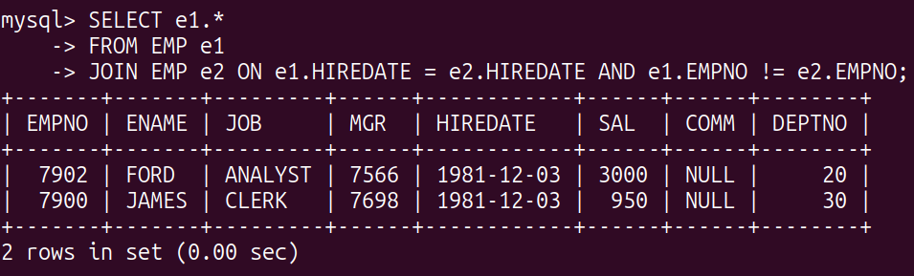

10. Find out the employees who joined the company before their Managers.

Commands:
SELECT e.*
FROM EMP e
JOIN EMP m ON e.MGR = m.EMPNO
WHERE e.HIREDATE < m.HIREDATE;

Output:

